Name (in Romaji):
Student Number:
Class Day + Period:

Liō

Liō is a daily comic strip created by American artist Mark Tatulli. It was first published on May 15, 2006. As a pantomime strip, it has an international appeal. In 2008, the strip brought Tatulli a National Cartoonists Society Newspaper Comic Strip Award.
The strip focuses on the adventures of a creative little boy, Liō, who lives with his father and various monsters, animals, aliens, lab creations, and other creatures. He has at least five companion animals, including:
- Ishmael, a giant squid
- Cybil, a white cat that looks sweet and innocent but is not
- Mittens, a lobster he rescued from his father’s planned dinner
The setting of the story ranges from Liō’s house to his school and the general outside world.
The story is told visually, with little or no dialogue. Gags frequently involve the supernatural, alien invasion, or mass destruction, thereby creating a surreal, disturbing atmosphere. Some of the strip’s recurring themes involve Liō getting even with grade-school bullies, helping animals defend themselves against humans or their predators (these animals tend to be non-anthropomorphic but display obvious intelligence), and performing mad scientist-style experiments. He is often seen using robots that he constructs himself for causing mischief.
In addition to Liō, the strip only has one other major character: Liō’s unnamed father. He is a good man, but he cannot control Liō. He is frequently shown to be the subject of Liō’s pranks, and sometimes he has to get his son out of difficult situations. For example, there was once an incidence when he saw a news report of an alien invasion. He ended up giving Liō a spanking because his son had piloted an alien ship and parked it in front of their house. Even so, one day when the boy came home from school dejected because a drawing he created had horrified the faculty, his father proudly put the piece of art on the refrigerator, giving his son much-needed comfort and joy. In the end, both love each other very much, no matter what.
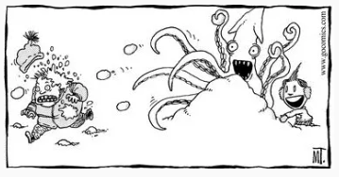

* * * * * * * * HOMEWORK TASK * * * * * * * *

Look at each comic strip. On a separate sheet, in your own words (1) explain what occurs in each strip, and (2) explain why readers would think what happened is humorous. The task should be printed out, ready for submission.

[1] | 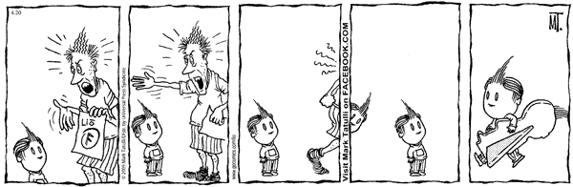
[2] | 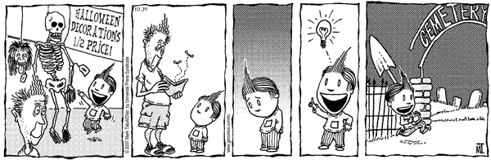
[3] | 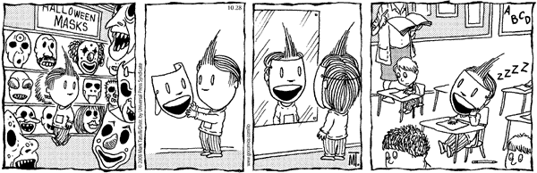
[4] | 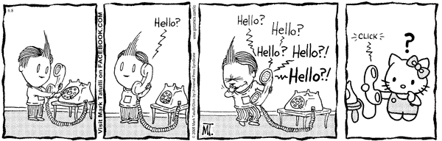
[5] | 